**Starbucks Vue**

(Recall that Chrome might have issues reading a local file.)

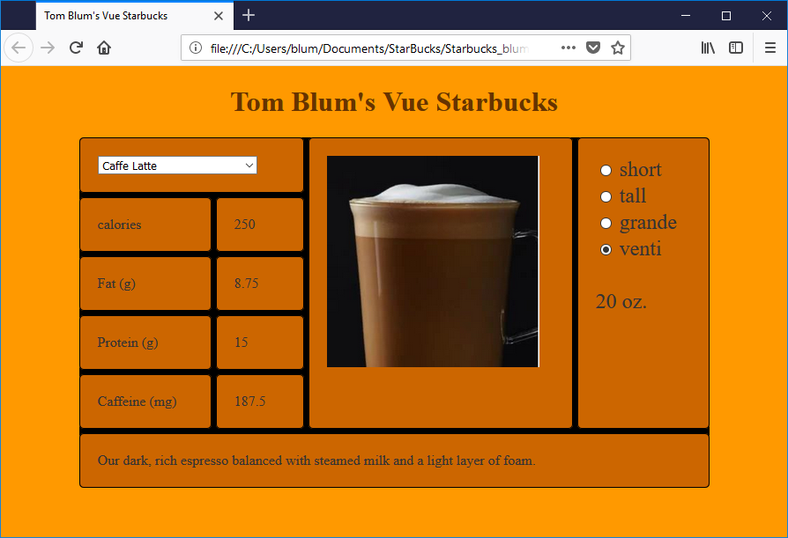

1. Use the headstart Starbucks.html. Add a title John Smith’s Vue Starbucks (with John Smith replaced by your name).
2. Add an HTML comment with your name.
3. Your HTML elements with ids cannot have default/meaningless ids such as Button1. They also cannot refer to some previous subject – such as books, movies, etc.
4. Make the **page**’s background color and (font) color anything other than the default values.
5. Change the “box” class style’s background color and color.
6. Put a header with John Smith’s VUE Starbucks (with John Smith replaced by your name) at the top of the page.
7. Link to the Vue code.
8. Place a JavaScript comment with your name at the top of the script area.
9. Use fetch to read the file starbucks.json. And use this information to set the properties of your Vue object. (You will lose some points if you change the format of the data file.)
10. Use React to create nine div’s. They all should have the class “box”. The individual features of the div’s are as follows:
    1. Spans two columns and contains a drop-down select (with drink names)
    2. Has a Grid Column of 3 and Grid Row starting in row 1 and spanning 5 rows and contains an image (with drink image). The image should have a height of 240
    3. Has a Grid Column of 4 and Grid Row starting in row 1 and spanning 5 rows and contains a set of radio buttons for drink sizes.
       1. Make the font-size 1.5em.
       2. Have the Grande size chosen when the user starts or refreshes the page.
       3. Below the radio buttons add a span element that displays the number of ounces in the user’s selected size.
       4. Clicking on the label should have the same effect as clicking on the radio buttons.
    4. Contains word “Calories”
    5. Displays the calories for the selected drink (and drink size)
    6. Contains the words “Fat (g)”
    7. Displays the fat for the selected drink (and drink size)
    8. Contains the words “Protein (g)”
    9. Displays the protein for the selected drink (and drink size)
    10. Contains the words “Caffeine (mg)”
    11. Displays the caffeine for the selected drink (and drink size)
    12. Has a Grid Row of 6 and Grid Column starting in column 1 and spanning 4 columns. It displays the selected drink description
11. The drop-down select should be loaded with drink names from the JSON file.
12. The displays (calories, fat, protein, caffeine) should update when the user changes the selected drink or the selected size. For example, if the user selects a Caffe Latte (fat content 3.5) in the Venti size (multiplicative factor of 2.5) then the fat displayed should be 8.75 (= 3.5*2.5).
13. The description should be updated.
14. The image should be updated.